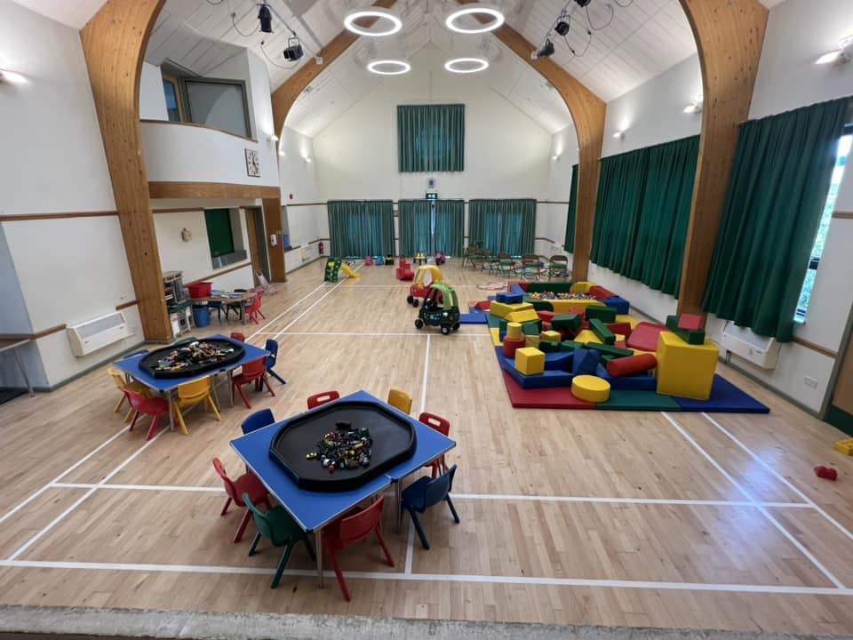
WHO RUNS THE GROUP:
Run by Volunteers that are First Aid, Health and Safety, Safeguarding and Mental Health Trained.
DAY/TIMES:
Thursday’s morning’s 9:45 – 11:30 term time only – St Mary Bourne Village Centre.
OVERVIEW OF THE GROUP:
To maintain and look after the Parish Toddler Group, a group that has been running for over 50 years and one we hope lasts another 50 years.
WHO IS THE GROUP FOR:
The group is for babies and toddlers, mum’s, dad’s, grandparents, and carers to meet. We hope to help new parents mix in new circles, welcome families into the group and the village and most of all have FUN!
WHAT HAPPENS AT THE GROUP:
We have a weekly craft, coffee and biscuits for the grown ups and a mixture of snacks and squash for the little ones. We have a baby corner and lots of soft play toys as well as scooter/coupe cars/pushchairs/babies. A puppet theatre and so much more!
FUNDRAISING:
To enable the group to continue, we need support from the local community:
- Attend the group.
- Support Fundraising events.

